**Course Code: CSE2067**

**Course Title: Web Technologies**

**Lab sheet 8 - Module 3**

**Problem Statement:**

Develop a java application with Employee class with Emp_name, Emp_id, Address, Mail_id, Mobile_no

as members. Inherit the classes, Programmer, Assistant Professor, Associate Professor and Professor

from employee class. Add Basic Pay (BP) as the member of all the inherited classes with 97% of BP as

DA, 10 % of BP as HRA, 12% of BP as PF, 0.1% of BP

for staff club fund. Generate pay slips for the employees with their gross and net salary

Write a PHP script to perform following file handling operation.

1. To open a file
2. To read a file line by line
3. To read a file character by character
4. To write a file
5. To append a file and close file.

**Program**

**To open a file**

<!DOCTYPE html>  
<html>  
<body>  
  
<?php  
$myfile=fopen("webdictionary.txt", "r") or die("Unable to open file!");  
echo fread($myfile,filesize("webdictionary.txt"));  
fclose($myfile);  
?>  
  
</body>  
</html>

**To read a file line by line**

<?php

$myfile = fopen("webdictionary.txt", "r") or die("Unable to open file!");

while(!feof($myfile)) {

echo fgets($myfile) . "<br>";

}

fclose($myfile);

?>

**To read a file character by character**

<?php

$myfile = fopen("webdictionary.txt", "r") or die("Unable to open file!");

// Output one character until end-of-file

while(!feof($myfile)) {

echo fgetc($myfile);

}

fclose($myfile);

?>

**To write a file**

<?php

$myfile = fopen("newfile.txt", "w") or die("Unable to open file!");

$txt = "John William\n";

fwrite($myfile, $txt);

$txt = "John Smith\n";

fwrite($myfile, $txt);

fclose($myfile);

?>

**To append a file and close file.**

<?php

$myfile = fopen("newfile.txt", "a") or die("Unable to open file!");

$txt = "Donald Duck\n";

fwrite($myfile, $txt);

$txt = “Harshith\n";

fwrite($myfile, $txt);

fclose($myfile);

?>

**Output**

**webdictionary.txt**

AJAX = Asynchronous JavaScript and XML  
CSS = Cascading Style Sheets  
HTML = Hyper Text Markup Language  
PHP = PHP Hypertext Preprocessor  
SQL = Structured Query Language  
SVG = Scalable Vector Graphics  
XML = EXtensible Markup Language

**To open a file**

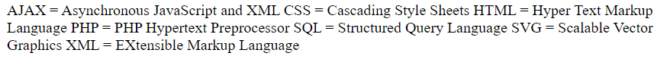

**To read a file line by line**

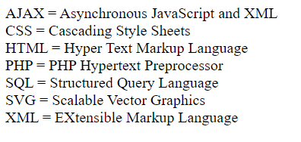

**To read a file character by character**



**To write a file**

John William

John Smith

**To append a file and close file.**

John William

John Smith

Donald Duck

Harshith